 NAME:Aryaman Mishra

**REG. NUMBER: 19BCE1027**

**EXPERIMENT NO.4**

**DATE: 25-2-22**

* **TITLE OF THE EXPERIMENT**

**Stroop Test**

* **AIM:**

To investigate how automatic processing interferes with controlled processing using a

variation of the Stroop interference task.

* **MATERIALS REQUIRED:**

<https://psych.hanover.edu/javatest/cle/Cognition_js/exp/stroop.html> Link

* **DESCRIPTION OF TEST:**

Why does the Stroop effect occur? We can tell our brain to do lots of things – store memories, sleep, think, etc. – so why can’t we tell it to do something as easy as naming a color? Isn’t that something we learn to do at a very young age?

Researchers have analyzed this question and come up with multiple different theories that seek to explain the occurrence of the Stroop effect (Sahinoglu & Dogan, 2016).

**Speed of processing theory:**

The processing speed theory claims that people can read words much faster than they can name colors (i.e., word processing is much faster than color processing).

When we look at the incongruent stimuli (the word “green” printed in red, for example), our brain first reads the word, making it much more difficult to then have to name the color.

As a result, a delay occurs when trying to name the color because doing so was not our brain’s first instinct (McMahon, 2013).

**Selective attention theory:**

The theory of [selective attention](https://www.simplypsychology.org/attention-models.html) holds that recognizing colors, compared to reading words, requires more attention.

Because of this, the brain needs to use more attention when attempting to name a color, making this process take slightly longer (McMahon, 2013).

**Automaticity:**

This theory argues that recognizing colors is not an automatic process, and thus there is a slight hesitancy when carrying out this action.

Automatic processing are processes in the mind that are relatively fast and require few cognitive resources. This type of information processing generally occurs outside of conscious awareness, and is common when undertaking familiar and highly practised tasks.

However, the brain is able to automatically understand the meaning of a word as a result of habitual reading (think back to Stroop’s initial study in 1935 – this theory explains why he wanted to test the effects of practice on the ability to name colors).

Researchers in support of this theory posit that automatic reading does not need controlled attention, but still uses enough of the brain’s attentional resources to reduce the amount left for color processing (Monahan, 2001).

In a way, this parallels the brain’s dueling modes of thinking – that of “System 1” and “System 2.” Whereas the former is more automatic and instinctive, the latter is slower and more controlled (Kahneman, 2011).

This is similar to the Stroop effect in which we see a more automatic process trying to dominate over a more deliberative one. The interference occurs when we try to use System 2 to override System 1, thus producing that delay in reaction time.

**Parallel distributed processing:**

The fourth and final theory proposes that when the brain completes different tasks, unique pathways are developed. Some of these pathways, such as reading words, are stronger than others, such as naming colors (Cohen et al., 1990).

Thus, the interference is not an issue of processing speed, attention, or automaticity, but rather a battle between the stronger and weaker neural pathways.

* **PROCEDURE**

In psychology, the Stroop effect is the delay in reaction time between automatic and controlled processing of information, in which the names of words interfere with the ability to name the colour of ink used to print the words.

The Stroop test requires individuals to view a list of words that are printed in a different color than the meaning of the word. Participants are tasked with naming the color of the word, not the word itself, as fast as they can.

For example, when presented with the word “green” that is written in red ink, it is much easier to name the word that is spelled, as opposed to the color ink in which the word is written.

Reading, a more powerful automatic process, takes some precedence over colour naming, which requires higher cognitive demands.

Since psychologist John Ridley Stroop first developed this paradigm back in 1935, the Stroop task has since been modified to help understand additional brain mechanisms and expanded to aid in brain damage and psychopathology research.

* **TABLE 1:** 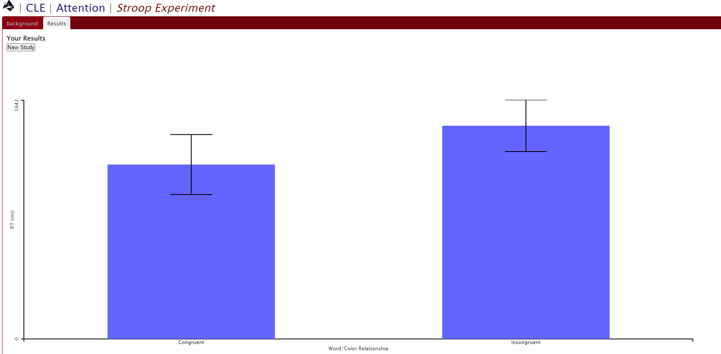

**INDIVIDUAL DISCUSSION**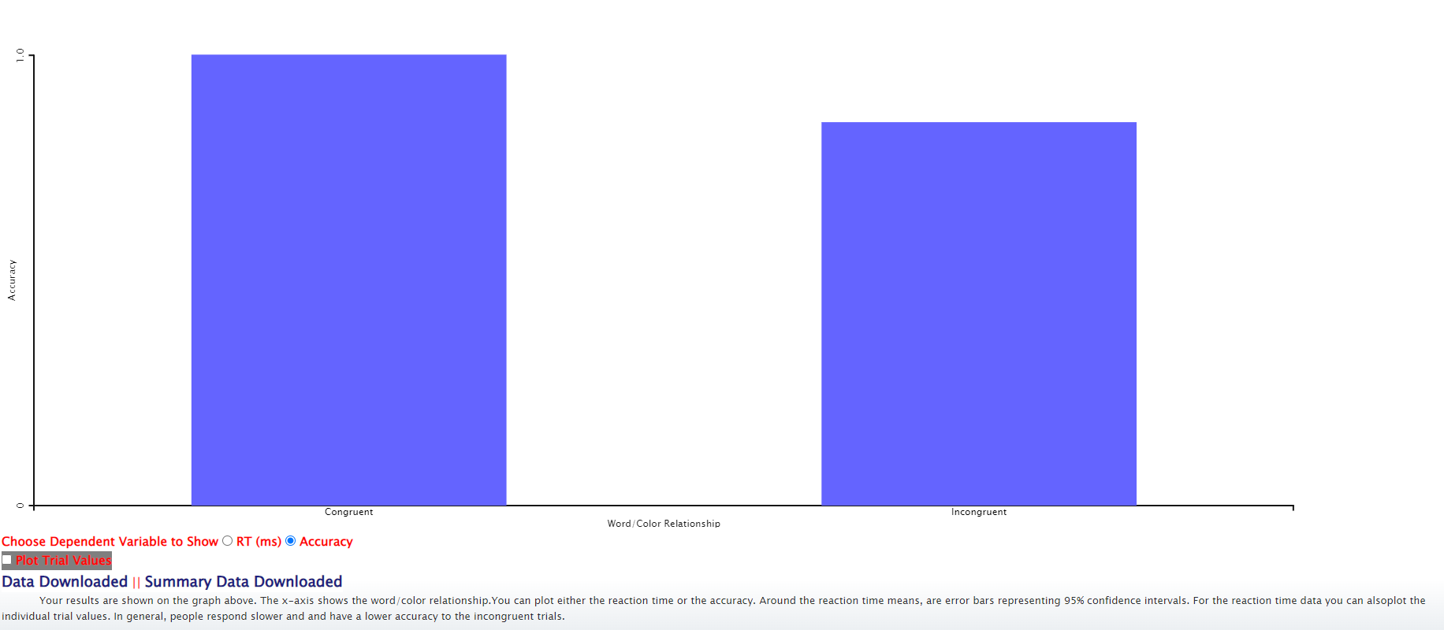

|  |  |  |  |  |  |  |  |  |  |  |  |  |  |  |  |  |  |  |  |  |  |  |  |  |  |  |  |  |  |  |  |
| --- | --- | --- | --- | --- | --- | --- | --- | --- | --- | --- | --- | --- | --- | --- | --- | --- | --- | --- | --- | --- | --- | --- | --- | --- | --- | --- | --- | --- | --- | --- | --- |
| Participant | Trial | Trials/Cond | Trial Dur (0=until resp) | Word/Color Relationship | Word/Color Relationship_val | Words | Words_val | Colors | Colors_val | Respond To: | Respond To:_val | Button Type | Button Type_val | Font Size | Word intensity | Background | Rel X Pos | Word Pos Random | Fix Duration | Use Makser | ISI | Gap Size (rel h) | Mask Dur (ms) | Word Fill | Show Fix When | Trial Delay | On Till Response | Stimulus Duration | Resp | RT (ms) | Accuracy |
| CLR070 | 1 | 20 | 0 | Congruent | 0 | YELLOW | 3 | YELLOW | 3 | The Color | 0 | Word | 0 | 24 | 255 | 0 | 0.5 | false | 1000 | false | 10 | 0 | 200 | Color | First | 1000 | true | 0 | 3 | 5200.2 | 1 |
| CLR070 | 2 | 20 | 0 | Congruent | 0 | BLUE | 2 | BLUE | 2 | The Color | 0 | Word | 0 | 24 | 255 | 0 | 0.5 | false | 1000 | false | 10 | 0 | 200 | Color | First | 1000 | true | 0 | 2 | 2256.1 | 1 |
| CLR070 | 3 | 20 | 0 | Congruent | 0 | RED | 0 | RED | 0 | The Color | 0 | Word | 0 | 24 | 255 | 0 | 0.5 | false | 1000 | false | 10 | 0 | 200 | Color | First | 1000 | true | 0 | 0 | 880.7 | 1 |
| CLR070 | 4 | 20 | 0 | Congruent | 0 | BLUE | 2 | BLUE | 2 | The Color | 0 | Word | 0 | 24 | 255 | 0 | 0.5 | false | 1000 | false | 10 | 0 | 200 | Color | First | 1000 | true | 0 | 2 | 905.2 | 1 |
| CLR070 | 5 | 20 | 0 | Congruent | 0 | RED | 0 | RED | 0 | The Color | 0 | Word | 0 | 24 | 255 | 0 | 0.5 | false | 1000 | false | 10 | 0 | 200 | Color | First | 1000 | true | 0 | 0 | 1498.5 | 1 |
| CLR070 | 6 | 20 | 0 | Congruent | 0 | GREEN | 1 | GREEN | 1 | The Color | 0 | Word | 0 | 24 | 255 | 0 | 0.5 | false | 1000 | false | 10 | 0 | 200 | Color | First | 1000 | true | 0 | 1 | 904.8 | 1 |
| CLR070 | 7 | 20 | 0 | Congruent | 0 | RED | 0 | RED | 0 | The Color | 0 | Word | 0 | 24 | 255 | 0 | 0.5 | false | 1000 | false | 10 | 0 | 200 | Color | First | 1000 | true | 0 | 0 | 887.2 | 1 |
| CLR070 | 8 | 20 | 0 | Congruent | 0 | BLUE | 2 | BLUE | 2 | The Color | 0 | Word | 0 | 24 | 255 | 0 | 0.5 | false | 1000 | false | 10 | 0 | 200 | Color | First | 1000 | true | 0 | 2 | 852.3 | 1 |
| CLR070 | 9 | 20 | 0 | Congruent | 0 | YELLOW | 3 | YELLOW | 3 | The Color | 0 | Word | 0 | 24 | 255 | 0 | 0.5 | false | 1000 | false | 10 | 0 | 200 | Color | First | 1000 | true | 0 | 3 | 1036.6 | 1 |
| CLR070 | 10 | 20 | 0 | Congruent | 0 | BLUE | 2 | BLUE | 2 | The Color | 0 | Word | 0 | 24 | 255 | 0 | 0.5 | false | 1000 | false | 10 | 0 | 200 | Color | First | 1000 | true | 0 | 2 | 910.4 | 1 |
| CLR070 | 11 | 20 | 0 | Congruent | 0 | GREEN | 1 | GREEN | 1 | The Color | 0 | Word | 0 | 24 | 255 | 0 | 0.5 | false | 1000 | false | 10 | 0 | 200 | Color | First | 1000 | true | 0 | 1 | 953.6 | 1 |
| CLR070 | 12 | 20 | 0 | Congruent | 0 | YELLOW | 3 | YELLOW | 3 | The Color | 0 | Word | 0 | 24 | 255 | 0 | 0.5 | false | 1000 | false | 10 | 0 | 200 | Color | First | 1000 | true | 0 | 3 | 1199 | 1 |
| CLR070 | 13 | 20 | 0 | Congruent | 0 | GREEN | 1 | GREEN | 1 | The Color | 0 | Word | 0 | 24 | 255 | 0 | 0.5 | false | 1000 | false | 10 | 0 | 200 | Color | First | 1000 | true | 0 | 1 | 1129.1 | 1 |
| CLR070 | 14 | 20 | 0 | Congruent | 0 | YELLOW | 3 | YELLOW | 3 | The Color | 0 | Word | 0 | 24 | 255 | 0 | 0.5 | false | 1000 | false | 10 | 0 | 200 | Color | First | 1000 | true | 0 | 3 | 964.7 | 1 |
| CLR070 | 15 | 20 | 0 | Congruent | 0 | GREEN | 1 | GREEN | 1 | The Color | 0 | Word | 0 | 24 | 255 | 0 | 0.5 | false | 1000 | false | 10 | 0 | 200 | Color | First | 1000 | true | 0 | 1 | 2722.5 | 1 |
| CLR070 | 16 | 20 | 0 | Congruent | 0 | YELLOW | 3 | YELLOW | 3 | The Color | 0 | Word | 0 | 24 | 255 | 0 | 0.5 | false | 1000 | false | 10 | 0 | 200 | Color | First | 1000 | true | 0 | 3 | 897.6 | 1 |
| CLR070 | 17 | 20 | 0 | Congruent | 0 | GREEN | 1 | GREEN | 1 | The Color | 0 | Word | 0 | 24 | 255 | 0 | 0.5 | false | 1000 | false | 10 | 0 | 200 | Color | First | 1000 | true | 0 | 1 | 818.4 | 1 |
| CLR070 | 18 | 20 | 0 | Congruent | 0 | BLUE | 2 | BLUE | 2 | The Color | 0 | Word | 0 | 24 | 255 | 0 | 0.5 | false | 1000 | false | 10 | 0 | 200 | Color | First | 1000 | true | 0 | 2 | 733.2 | 1 |
| CLR070 | 19 | 20 | 0 | Congruent | 0 | YELLOW | 3 | YELLOW | 3 | The Color | 0 | Word | 0 | 24 | 255 | 0 | 0.5 | false | 1000 | false | 10 | 0 | 200 | Color | First | 1000 | true | 0 | 3 | 999.6 | 1 |
| CLR070 | 20 | 20 | 0 | Congruent | 0 | GREEN | 1 | GREEN | 1 | The Color | 0 | Word | 0 | 24 | 255 | 0 | 0.5 | false | 1000 | false | 10 | 0 | 200 | Color | First | 1000 | true | 0 | 1 | 1134.9 | 1 |
| CLR070 | 21 | 20 | 0 | Incongruent | 1 | BLUE | 2 | RED | 0 | The Color | 0 | Word | 0 | 24 | 255 | 0 | 0.5 | false | 1000 | false | 10 | 0 | 200 | Color | First | 1000 | true | 0 | 0 | 1545.6 | 1 |
| CLR070 | 22 | 20 | 0 | Incongruent | 1 | RED | 0 | BLUE | 2 | The Color | 0 | Word | 0 | 24 | 255 | 0 | 0.5 | false | 1000 | false | 10 | 0 | 200 | Color | First | 1000 | true | 0 | 2 | 1159.3 | 1 |
| CLR070 | 23 | 20 | 0 | Incongruent | 1 | BLUE | 2 | YELLOW | 3 | The Color | 0 | Word | 0 | 24 | 255 | 0 | 0.5 | false | 1000 | false | 10 | 0 | 200 | Color | First | 1000 | true | 0 | 1 | 5197.6 | 0 |
| CLR070 | 24 | 20 | 0 | Incongruent | 1 | YELLOW | 3 | BLUE | 2 | The Color | 0 | Word | 0 | 24 | 255 | 0 | 0.5 | false | 1000 | false | 10 | 0 | 200 | Color | First | 1000 | true | 0 | 2 | 1505.7 | 1 |
| CLR070 | 25 | 20 | 0 | Incongruent | 1 | GREEN | 1 | YELLOW | 3 | The Color | 0 | Word | 0 | 24 | 255 | 0 | 0.5 | false | 1000 | false | 10 | 0 | 200 | Color | First | 1000 | true | 0 | 1 | 5017.8 | 0 |
| CLR070 | 26 | 20 | 0 | Incongruent | 1 | YELLOW | 3 | BLUE | 2 | The Color | 0 | Word | 0 | 24 | 255 | 0 | 0.5 | false | 1000 | false | 10 | 0 | 200 | Color | First | 1000 | true | 0 | 2 | 1204 | 1 |
| CLR070 | 27 | 20 | 0 | Incongruent | 1 | BLUE | 2 | YELLOW | 3 | The Color | 0 | Word | 0 | 24 | 255 | 0 | 0.5 | false | 1000 | false | 10 | 0 | 200 | Color | First | 1000 | true | 0 | 1 | 5712.9 | 0 |
| CLR070 | 28 | 20 | 0 | Incongruent | 1 | RED | 0 | GREEN | 1 | The Color | 0 | Word | 0 | 24 | 255 | 0 | 0.5 | false | 1000 | false | 10 | 0 | 200 | Color | First | 1000 | true | 0 | 1 | 3332.9 | 1 |
| CLR070 | 29 | 20 | 0 | Incongruent | 1 | BLUE | 2 | RED | 0 | The Color | 0 | Word | 0 | 24 | 255 | 0 | 0.5 | false | 1000 | false | 10 | 0 | 200 | Color | First | 1000 | true | 0 | 0 | 1289.4 | 1 |
| CLR070 | 30 | 20 | 0 | Incongruent | 1 | RED | 0 | GREEN | 1 | The Color | 0 | Word | 0 | 24 | 255 | 0 | 0.5 | false | 1000 | false | 10 | 0 | 200 | Color | First | 1000 | true | 0 | 1 | 2384.9 | 1 |
| CLR070 | 31 | 20 | 0 | Incongruent | 1 | YELLOW | 3 | BLUE | 2 | The Color | 0 | Word | 0 | 24 | 255 | 0 | 0.5 | false | 1000 | false | 10 | 0 | 200 | Color | First | 1000 | true | 0 | 2 | 1333.9 | 1 |
| CLR070 | 32 | 20 | 0 | Incongruent | 1 | BLUE | 2 | RED | 0 | The Color | 0 | Word | 0 | 24 | 255 | 0 | 0.5 | false | 1000 | false | 10 | 0 | 200 | Color | First | 1000 | true | 0 | 0 | 981.5 | 1 |
| CLR070 | 33 | 20 | 0 | Incongruent | 1 | RED | 0 | YELLOW | 3 | The Color | 0 | Word | 0 | 24 | 255 | 0 | 0.5 | false | 1000 | false | 10 | 0 | 200 | Color | First | 1000 | true | 0 | 3 | 1290.5 | 1 |
| CLR070 | 34 | 20 | 0 | Incongruent | 1 | BLUE | 2 | RED | 0 | The Color | 0 | Word | 0 | 24 | 255 | 0 | 0.5 | false | 1000 | false | 10 | 0 | 200 | Color | First | 1000 | true | 0 | 0 | 1110.1 | 1 |
| CLR070 | 35 | 20 | 0 | Incongruent | 1 | YELLOW | 3 | BLUE | 2 | The Color | 0 | Word | 0 | 24 | 255 | 0 | 0.5 | false | 1000 | false | 10 | 0 | 200 | Color | First | 1000 | true | 0 | 2 | 1273.6 | 1 |
| CLR070 | 36 | 20 | 0 | Incongruent | 1 | GREEN | 1 | RED | 0 | The Color | 0 | Word | 0 | 24 | 255 | 0 | 0.5 | false | 1000 | false | 10 | 0 | 200 | Color | First | 1000 | true | 0 | 0 | 1133 | 1 |
| CLR070 | 37 | 20 | 0 | Incongruent | 1 | YELLOW | 3 | GREEN | 1 | The Color | 0 | Word | 0 | 24 | 255 | 0 | 0.5 | false | 1000 | false | 10 | 0 | 200 | Color | First | 1000 | true | 0 | 1 | 1581.3 | 1 |
| CLR070 | 38 | 20 | 0 | Incongruent | 1 | GREEN | 1 | YELLOW | 3 | The Color | 0 | Word | 0 | 24 | 255 | 0 | 0.5 | false | 1000 | false | 10 | 0 | 200 | Color | First | 1000 | true | 0 | 3 | 1465.5 | 1 |
| CLR070 | 39 | 20 | 0 | Incongruent | 1 | RED | 0 | GREEN | 1 | The Color | 0 | Word | 0 | 24 | 255 | 0 | 0.5 | false | 1000 | false | 10 | 0 | 200 | Color | First | 1000 | true | 0 | 1 | 1390.6 | 1 |
| CLR070 | 40 | 20 | 0 | Incongruent | 1 | GREEN | 1 | YELLOW | 3 | The Color | 0 | Word | 0 | 24 | 255 | 0 | 0.5 | false | 1000 | false | 10 | 0 | 200 | Color | First | 1000 | true | 0 | 3 | 3960.4 | 1 |

|  |  |  |  |  |  |  |  |  |  |  |  |  |  |  |  |  |  |  |  |  |  |  |  |  |  |  |
| --- | --- | --- | --- | --- | --- | --- | --- | --- | --- | --- | --- | --- | --- | --- | --- | --- | --- | --- | --- | --- | --- | --- | --- | --- | --- | --- |
| Participant | Trials/Cond | Trial Dur (0=until resp) | Respond To: | Respond To:_val | Button Type | Button Type_val | Font Size | Word intensity | Background | Rel X Pos | Word Pos Random | Fix Duration | Use Makser | ISI | Gap Size (rel h) | Mask Dur (ms) | Word Fill | Show Fix When | Trial Delay | On Till Response | Stimulus Duration | Congruent_RT (ms) | Incongruent_RT (ms) | Congruent_Accuracy | Incongruent_Accuracy |  |
| CLR070 | 20 | 0 | The Color | 0 | Word | 0 | 24 | 255 | 0 | 0.5 | FALSE | 1000 | FALSE | 10 | 0 | 200 | Color | First | 1000 | TRUE | 0 | 1344.23 | 1643.659 | 1 | 0.85 |  |

* **TABLE 2:**

**GROUP DISCUSSION**

**No group data provided-Stroop test has been classified as an individual experiment.**

* **CONCLUSION**

Data from the Stroop Test has been succesfully recorded.

­­­­­­­­­­­­